1. **Explain in detail the area graphs and line graphs in tableau and how to create them with examples. (With the help of an example create one in tableau)**

**Line Graphs:**

**Definition:** A line graph is a type of chart that displays information using a series of data points called 'markers' connected by straight line segments. It is commonly used to represent data over a continuous interval or time span.

**Creating a Line Graph in Tableau:**

1. **Data Preparation:**

* Open Tableau and connect to your data source.
* Drag the required dimensions and measures onto the rows and columns shelves.

1. **Building the Line Graph:**

* Drag the dimension (e.g., Date) to the Columns shelf.
* Drag the measure (e.g., Sales) to the Rows shelf.
* Tableau automatically creates a line graph.

1. **Customization:**

* You can customize the appearance by adding labels, tool-tips, and formatting axes.
* To add more lines, you can drag additional dimensions or measures to the Detail or Color shelf.

**Area Graphs:**

**Definition:** An area graph is similar to a line graph but the area between the line and the axis is filled with color. It's useful for visualizing the cumulative total of a measure over time.

**Creating an Area Graph in Tableau:**

1. **Data Preparation:**

* Follow the same data preparation steps as for the line graph.

1. **Building the Area Graph:**

* Create a line graph as described above.
* Right-click on the line on the view and select "Area" from the options.

1. **Customization:**

* Customize the appearance by adjusting the color, transparency, and other formatting options.
* Add labels, tool-tips, and legends to enhance the information presented.

**In Tableau:**

**Prerequisites**: Superstore Data-source provided by Tableau, which includes three tables: orders, people, and returns.

**Orders Table**:

Columns: Order ID, Order Date, Ship Date, Ship Mode, Customer Name, Segment, Country/Region, City, State, Province, Category

**People Table**:

Columns: Regional Manager

**Returns Table**:

Columns: Returned

* Select the order date and drag it to the columns.
* Select profit measure and drag it to rows.
* Click on the order date drop-down and select discrete to continuous.
* You will see a line graph.

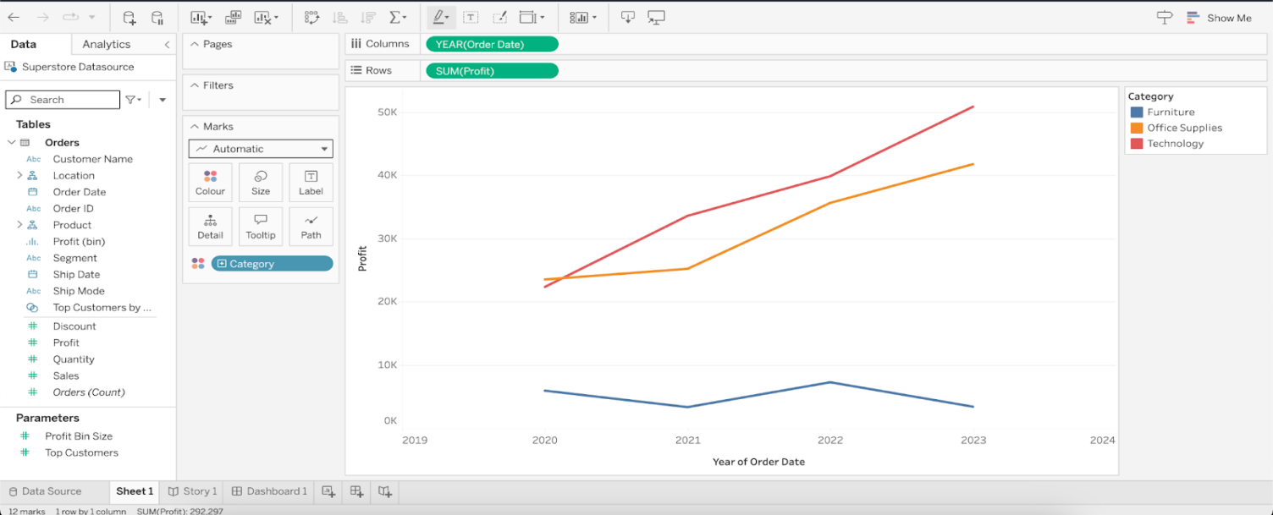

* Change Marks from automatic to Area chart.

